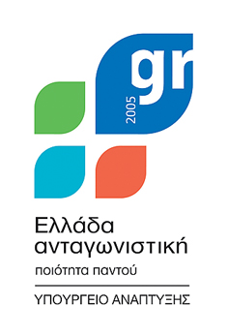




ΕΠΙΜΕΛΗΤΗΡΙΟ ΗΡΑΚΛΕΙΟΥ
CHAMBER OF HERAKLION



ΕΛΛΗΝΙΚΗ ΔΗΜΟΚΡΑΤΙΑ
HELLENIC REPUBLIC

2nd INSULEUR EXECUTIVE TRAINING PROGRAMME
25-26 JUNE 2009
HERAKLION CHAMBER – KASTELLAKI CONGRESS HALL
(9, koronaiou Str., Heraklion, Crete, Greece)

REGISTRATION FORM
To return duly filled in before June 8th, 2009
by email: insuleur@camaras.org
or by fax: +32 270 56 640
*Please attach the proof of payment with the registration form

Mrs / Mr:
LAST NAME / First Name:POSITION:
REGION/ORGANISATION:
ADDRESS:
TEL.: FAX:
EMAIL:
ARRIVAL DATE : ARRIVAL TIME:

FLIGHT Nº : DEPARTURE DATE : DEPARTURE TIME :

FLIGHT Nº :

FURTHER INFORMATION
For any further information, please contact:
Ms. Yolanda Segui
Technical Committee Insuleur
Telephone: +32 270 60 896
Fax: +32 270 56 640
Email: insuleur@camaras.org

