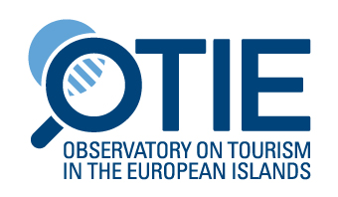

Press release
EUROPEAN POLICIES TO SUPPORT EUROPEAN ISLANDS As sustainable tourist destinationS

A Public Hearing was organised on 14 December 2018 by the Network of the Insular Chambers of Commerce and Industry of the EU (INSULEUR), and the Observatory on Tourism in the European Islands (OTIE), in partnership with the European Economic and Social Committee, and the support of the CPMR Island Commission and the European Small Islands Federation.

At the Pubic Hearing, delegates stressed that sustainable tourism takes full account of its current and future economic, social and environmental impacts, addressing the needs of visitors, the industry, the environment and host communities. Sustainable tourism should thus make optimal use of environmental resources, respect host communities and ensure viable, long-term economic operations, providing benefits that are distributed fairly among all stakeholders.

The most widely used tourism development model in islands is based on seaside summer holidays (‘sun and sea’), and the attainment of quantitative goals. Islands, as tourist destinations face great pressure from tourism and need to provide the high quality, sustainable environments desired by tourists.

Insular business associations and representatives of organisations dealing with insular development presented their positions regarding new trends in the tourism sector (low-cost carriers, sharing economy Airbnb, overtourism etc) and stressed that the European Institutions should help support islands through different European Policies – transport, energy, tourism, and environment, circular economy – to preserve the sustainability of their tourism product.

European Commission representatives presented policies and other financial instrument in favour of islands. The implementation of such policies would help and assist destination managers and tourism stakeholders in islands to identify and implement innovative and relevant planning, and to develop and market processes for managing tourism in their islands.

CPMR Secretary General, Eleni Marianou, said: “We are delighted to support this high-level event, aimed at finding solutions to many of the sustainable tourism challenges faced by the CPMR’s island regions. The CPMR will continue to actively work on these issues within our Islands and Intermediterranean Commissions, and as a partner in cooperation projects between EU islands.”
The President of INSULEUR Mr. Joseph Borg stated that “INSULEUR is requesting EU Institutions to proceed with their vision to ensure sustainable tourism in EU islands. Initiatives have to have proper funding backing them. Only in this way can islands reap the full benefit”.

President of OTIE Mr. Giovanni Ruggieri noted “the necessity to capitalize the projects done in the EU Islands, starting a concrete networking between the islands to share best practices and to transfer the best one to the islands system”.

