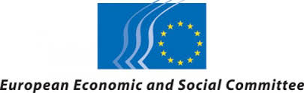

** **

**Press release**

**Are European Policies suitable to help doing business on Islands?**

A Public Hearing was organized in Brussels by the Network of the Insular Chambers of Commerce and Industry of the EU (INSULEUR) in partnership with the European Economic and Social Committee (EESC) and the cooperation of European Small Islands Federation (ESIN), on Friday, April 5, 2019.

This Public Hearing was a follow-up of the “Smart Island” and “Inclusive Island” initiatives adopted by the EESC and the opinion on “Entrepreneurship on Islands: contributing towards territorial cohesion”, adopted by the Committee of Regions.

The discussions examined if existing policies and tools to support SMEs were sufficient for insular SMEs or some new tools or mechanisms, mentioned also in the opinions, are needed to help these companies to tackle obstacles and participate on an equal foot in the integration process and assure therefore *a level playing field*.

It focused on the specific barriers and obstacles of insular SMEs and examined if the existing policies European Policies meet the needs of insular SMEs. Special attention was given to the following policies: **Cohesion Policy, State Aid rules: exemptions, Access to markets, Taxation policy and reduced VAT rates for Islands, transport and accessibility and migration and refugees**

Introducing the Public Hearing President Joseph Borg, President of Insuleur, said “that it is more difficult to do business on islands because of problems related mainly to connectivity and the transportation of goods and services. The EU has to give more attention to communities that are in difficulty.”